EXP 8 K MANOJ KIRAAN
240701305
Create Workflow Using Zoho Creator

Aim
To create and implement workflows in Zoho Creator to automate activities in the EviTrace Digital Evidence Chain-of-Custody and Investigation Tracking System.

Procedure
- Open the EviTrace application in Zoho Creator.
- Navigate to Workflow → Form Workflows.
- Configure workflows for forms such as Investigation Cases, Evidence Registry, Chain of Custody, Forensic Examination, Integrity Verification, and Investigation Reports.
- Set appropriate form events, such as record creation and successful form submission, to trigger the workflows.
- Create the Deluge function Log_Investigation_Event to record audit details such as event type, related record ID, date and time, and action details.
- Configure the relevant workflow to call the audit function when a record is created.
- Create the Log_Custody_Transfer workflow to automate custody-transfer activities.
- Save and test the workflows.

Output

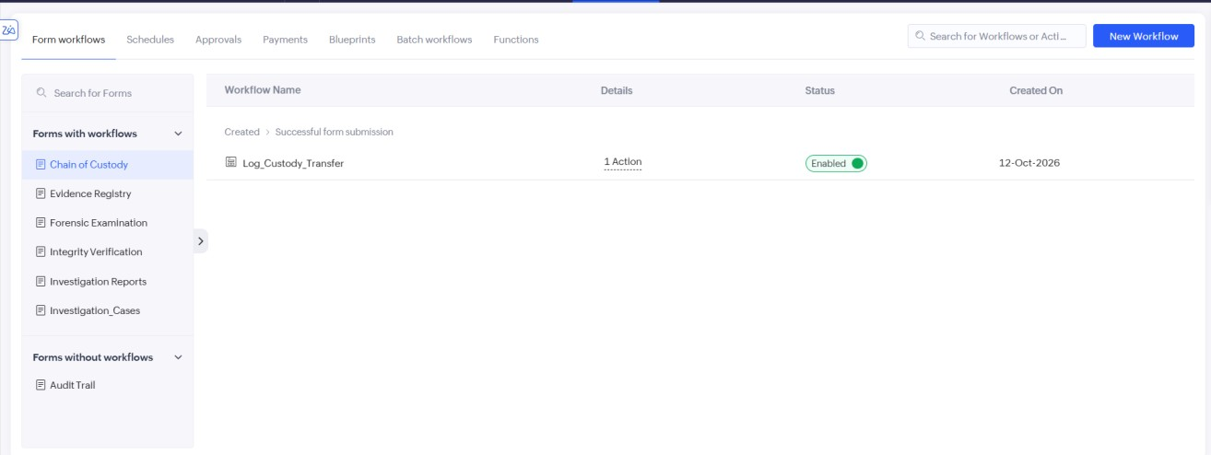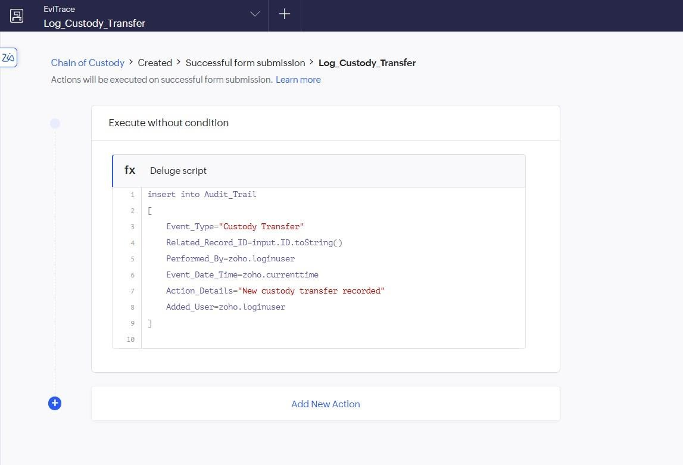
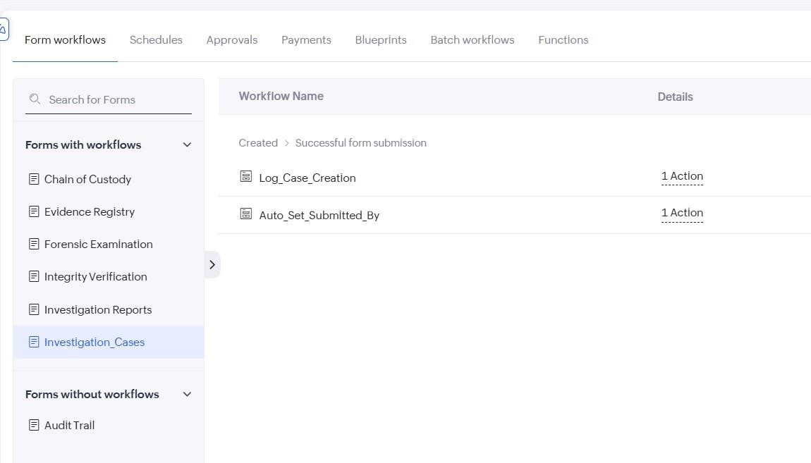
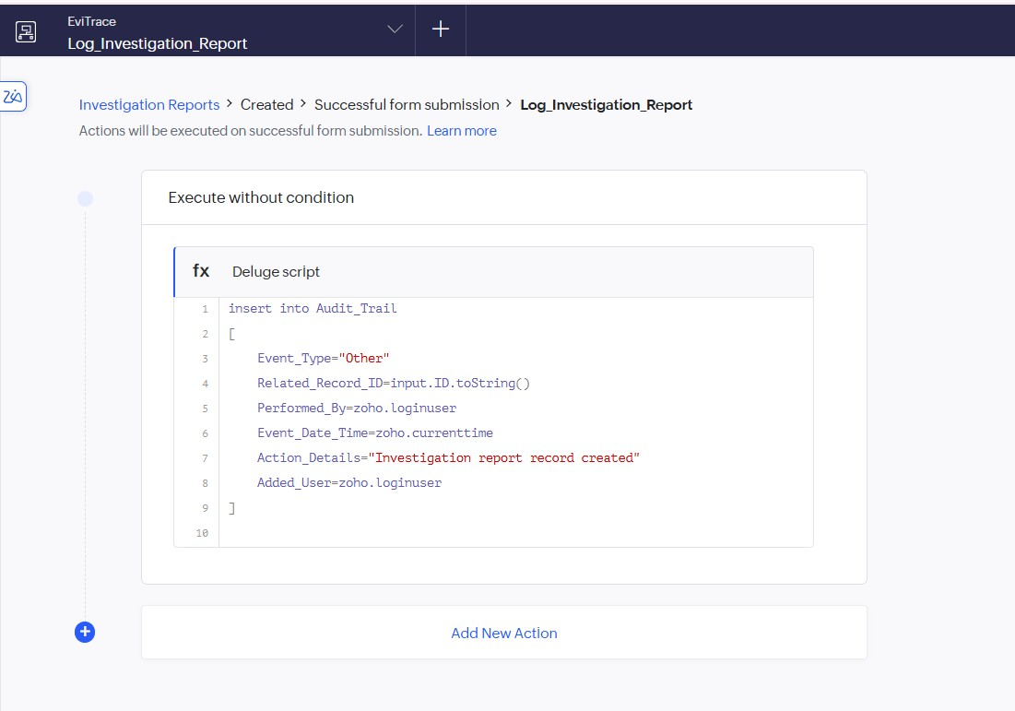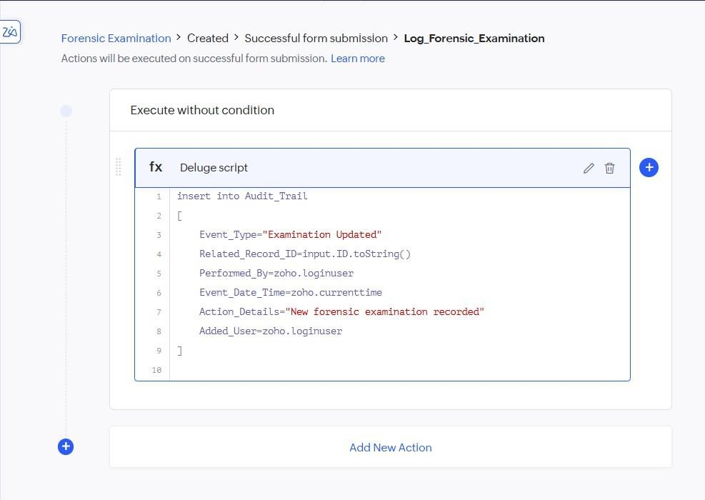

Result
Form workflows were configured in Zoho Creator to automate custody-transfer activities and audit logging in the EviTrace application.

